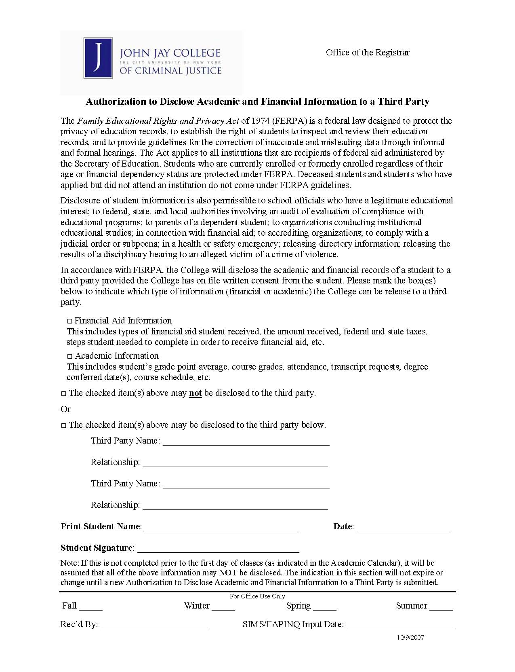
Jennifer Soto a/k/a Burgos
x
Axiom Requisition Copy Service as agent of Goergen, Manson & Huenke
Order No.: 01-24096-004
x

